Project Development Phase
Flow Designer Performance & Automation Test
Date | 29 September 2026
Team ID | SWTID-2026-9791
Project Name | Streamlining IT Procurement: Automating Standard Laptop Orders with Flow Designer
Maximum Marks | 4 Marks
Team Size | 3
Team Leader | MONIKA S
Team Member | PREETHA S
Team Member | RANJANI DEVI M

IT Procurement Flow Designer Performance Testing:
Project team shall fill the following information in the IT Procurement Flow Designer performance testing template.
S.No. | Parameters | Values | Screenshot
1. | Flow Designer Automation Summary | • Flow Designer triggers automatically upon 'Standard Business Laptop' Service Catalog request.  • Auto-routes manager approval based on requester profile.  • Automated task generation for IT fulfillment (SCTASK). | 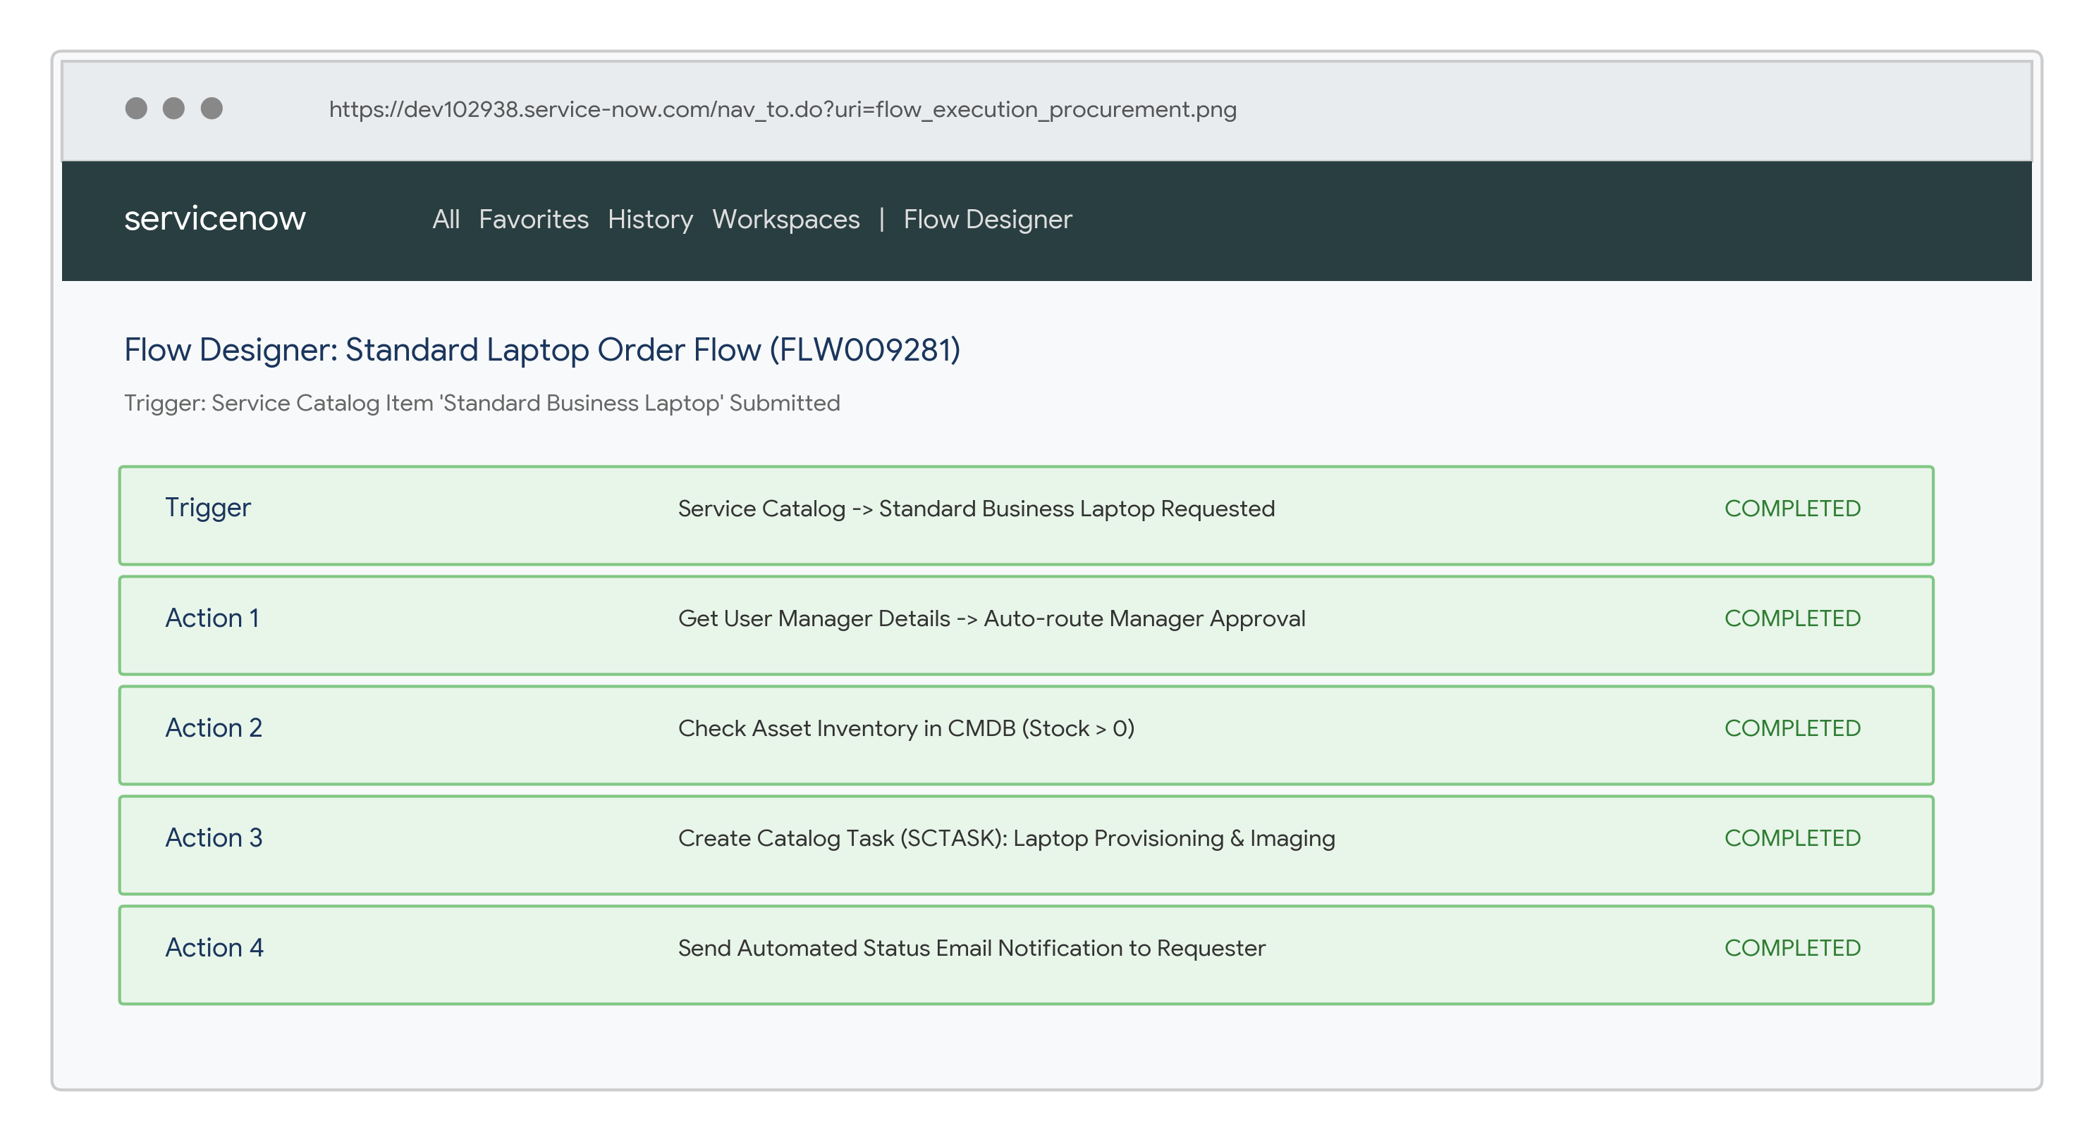
2. | Fulfillment Accuracy & RITM Processing | Standard Order Scenario – Catalog order submitted by employee: Manager approval and RITM fulfillment created automatically.  Asset Tracking – Order stage updated dynamically across Catalog Item, RITM, and Asset tables. | 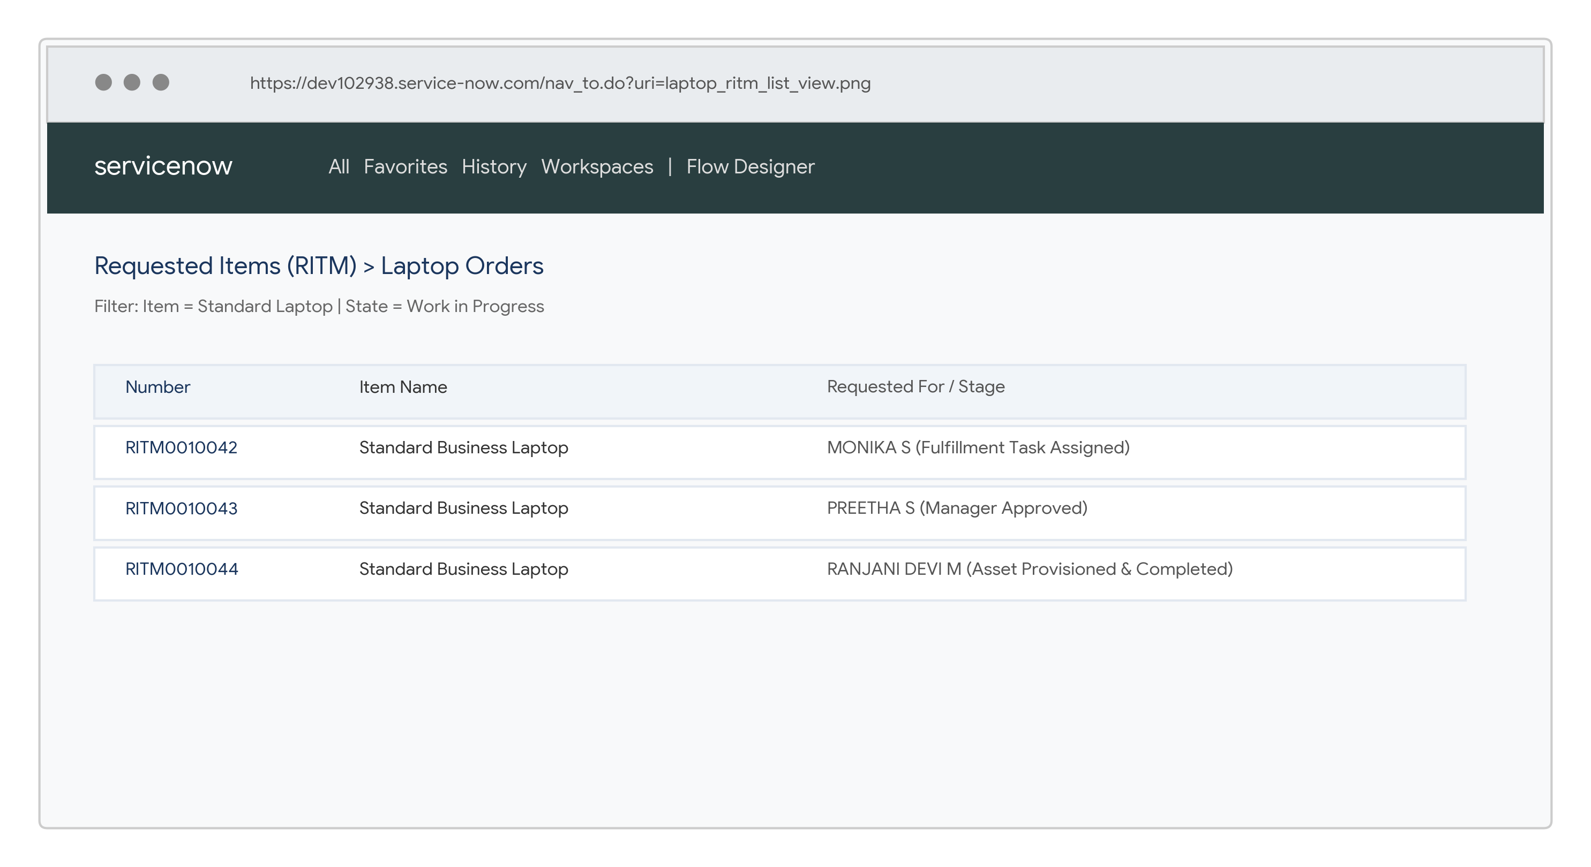
3. | Rule Tuning & Subflow Result | Validation Result – Flow Designer actions and asset availability subflows tested with multi-department requests.  Expected Result – Approved orders automatically assign fulfillment tasks and update CMDB stock records. | 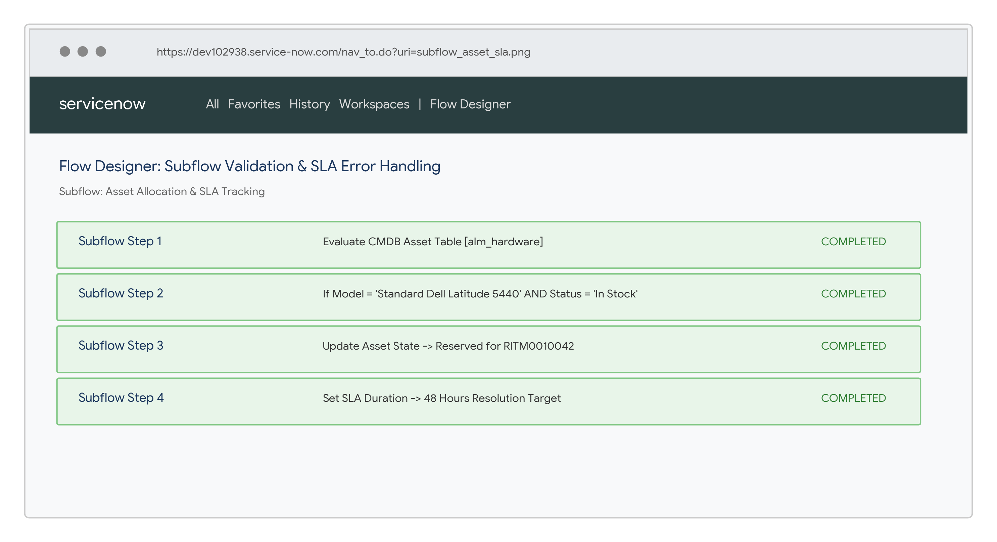

Performance / Validation Criteria:
• Flow Designer evaluates standard laptop requests instantly upon catalog submission.
• Manager approvals are routed automatically without requiring manual assignment.
• CMDB asset stock is verified automatically before fulfillment tasks are issued.
• Notifications and stage updates are triggered seamlessly, ensuring SLA compliance.

